17 February 2025

ACCEPTANCE LETTER

Client: City of Tshwane

BID NO: ROC 07 – 2022/23

Dear Sir/Madam

On behalf of SITHEMBE TRANSPORTATION AND PROJECTS, I hereby accept the appointment letter dated 06 February 2025, for the tender: TENDER FOR THE HORTICULTURAL MAINTENANCE OF SPORT FACILITIES IN SEVEN REGIONS OF TSHWANE: AS AND WHEN REQUIRED: THREE (3) YEAR PERIOD: WITH THE EFFECT FROM 15 FEBRUARY 2025 OR NEAREST DATE.

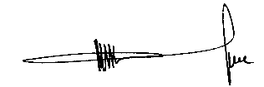
……………………………………………
MR. M.V LUKHELE
Director

